AXI4-lite_LED_SevenSeg_IRQ
Overview
- Memory-mapped AXI4-Lite slave peripheral
- Provides control and status interface for external hardware
- Designed for simple register-based communication
Core Functionalities
- Controls 8-bit LED output
- Controls 8-bit seven-segment display
- Generates edge-triggered interrupt (IRQ)
- Provides software-accessible registers for control and status
AXI Interface Features
- Independent read and write channels
- Standard VALID/READY handshake mechanism
- One outstanding read transaction
- One outstanding write transaction
Register Access Features
- Memory-mapped register interface
- Byte-wise write operations using WSTRB
- Synchronous register updates
- Address decoding based on word-aligned addressing
Supported Features
- AXI4-Lite compliant interface
- Independent read/write handling
- Single outstanding transaction per channel
- Byte-enable support (WSTRB)
- Edge-triggered interrupt generation
- W1C interrupt clearing
- Fully synchronous design
Unsupported / Limitations
- No burst transfers
- No multiple outstanding transactions
- No out-of-order responses
- No unaligned accesses
- No support for AXI IDs

Bugs/ Issues identified
During Compilation
1. Compile with vcs
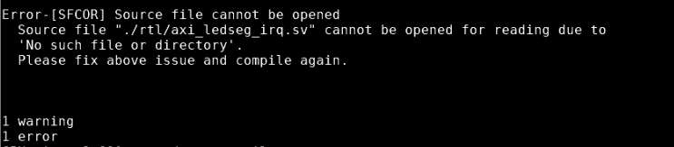

->Correct the rtl path in and the extension of the design file in makefile
2.
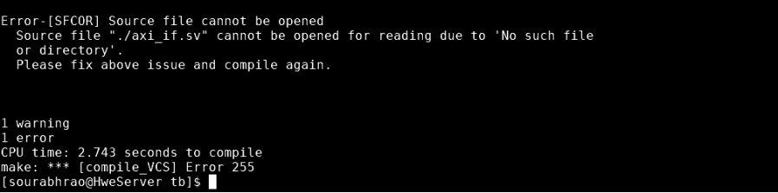
-> Added full path in Makefile
3.
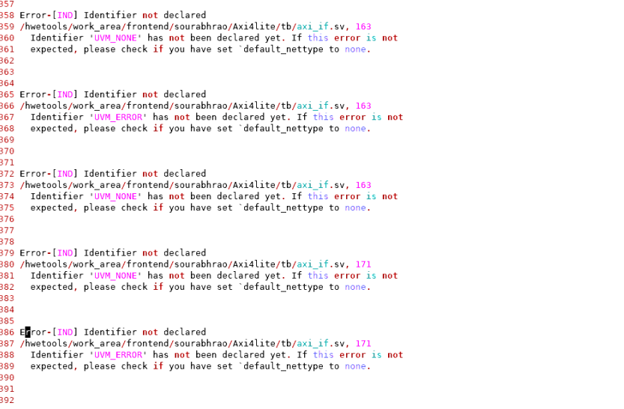
-> Import uvm_pkg::* in interface file
4.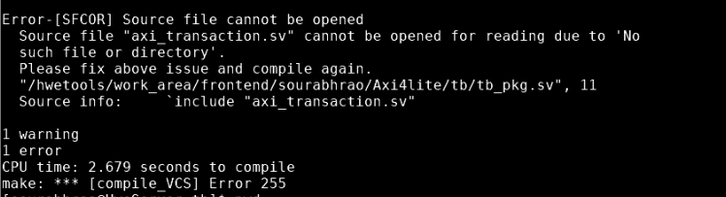
-> Added full path in tb_pkg.sv for all components
5. Changed output_monitor to axi_monitor in env and pkg
6. In scoreboard commented analysis_fifo for output monitor
7. clk and rst_n not instantiated with the dut
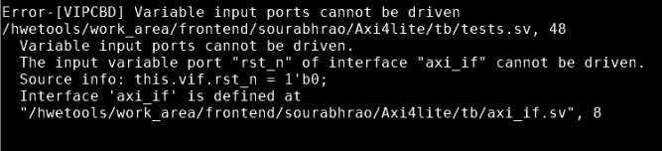
-> In tb_top.sv declare clk and in axi_if.sv declare rst_n signal
-> Compilation error free

During simulation
Run_reset test
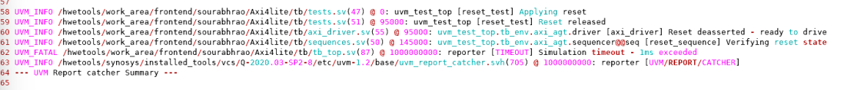

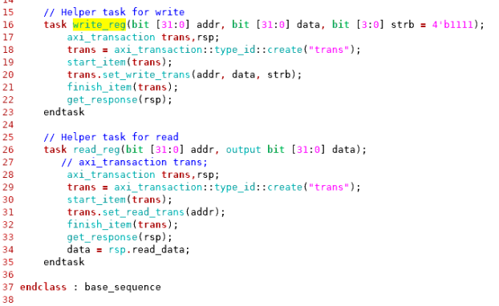

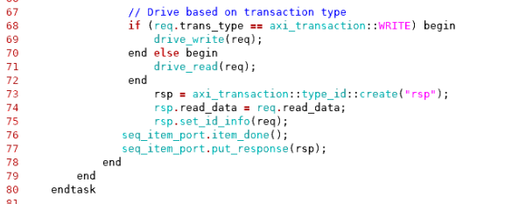

- The sequence was calling get_response() to wait for a response transaction from the driver.
- But, the driver was not sending any response using put_response().
- Because of this, the sequence remained blocked, continuously waiting for a response.
- This blocking condition eventually resulted in a simulation timeout error.
- The issue was resolved by modifying the driver to send the response transaction back to the sequence using put_response().

Waveform
1. Reset_test
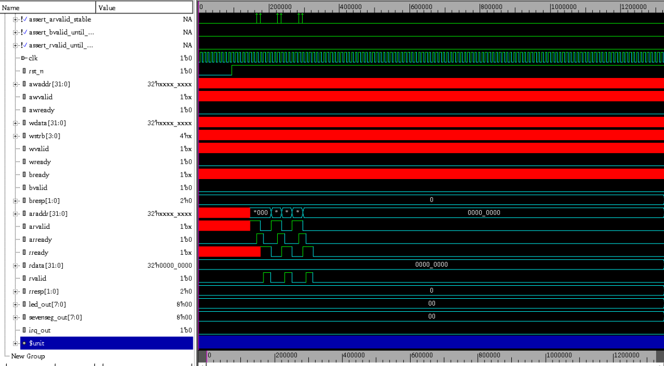

2. Baisc_write_test
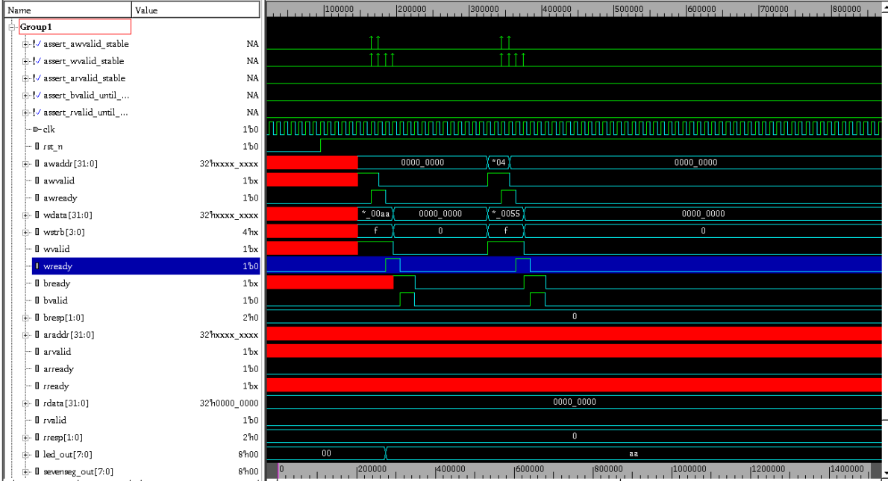

3. Basic_read_test
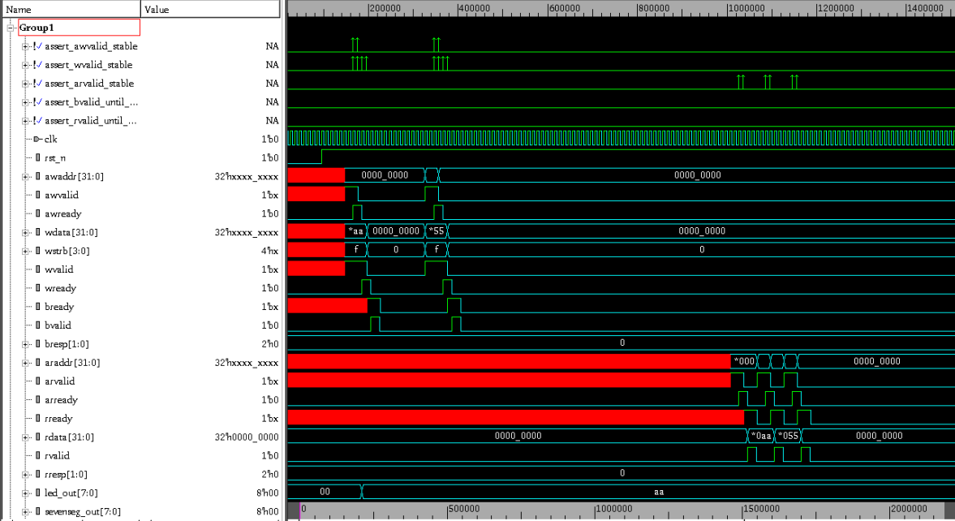

4. Protocol_test
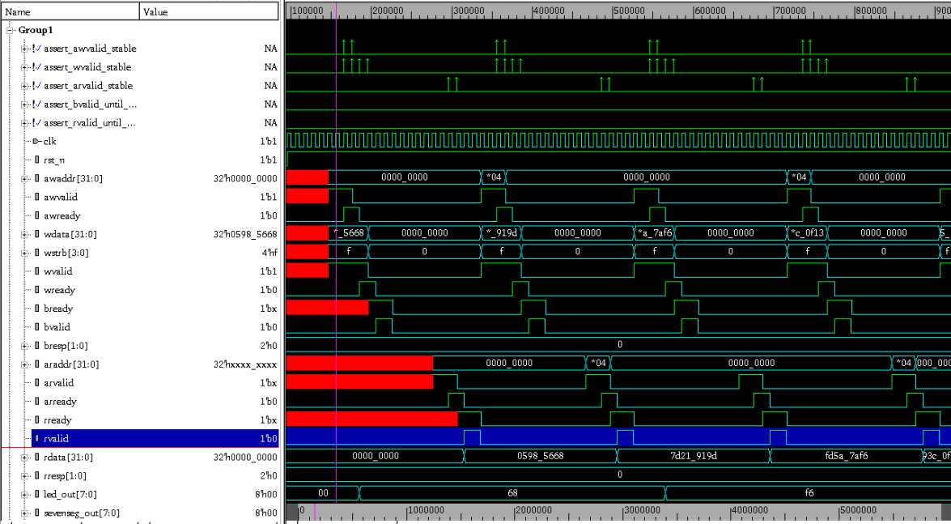

5. Wstrb_test
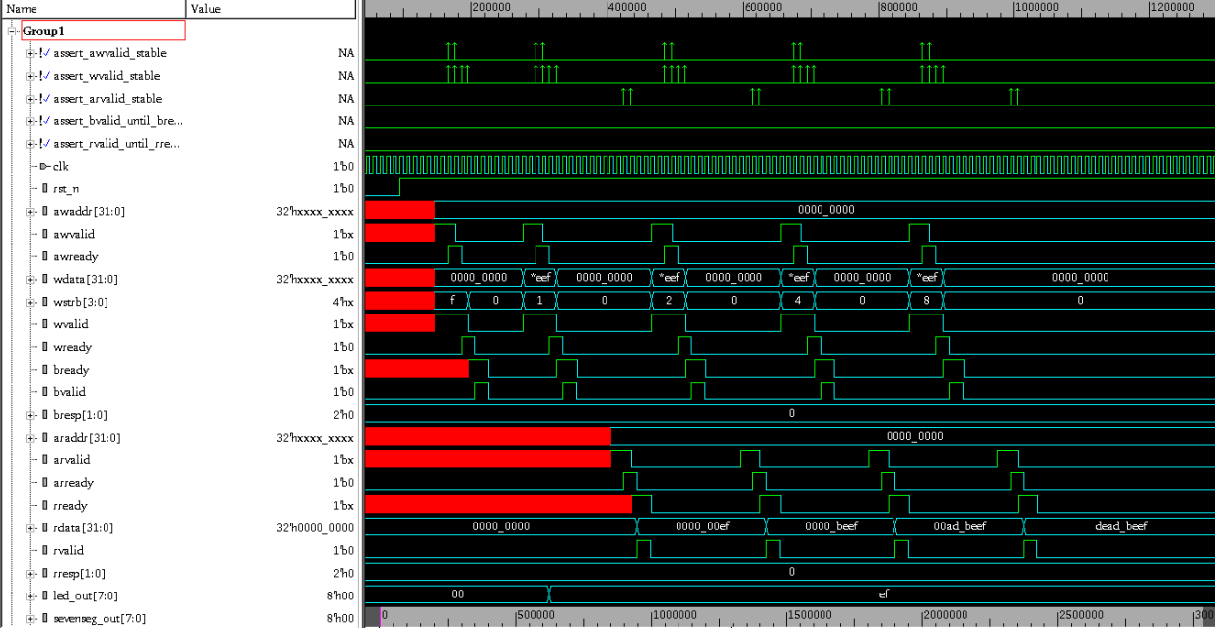

6. Irq_test
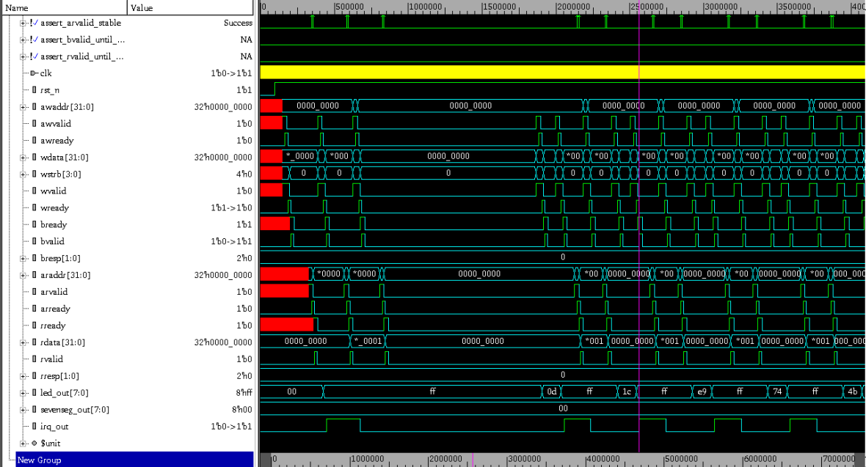

7. Register test
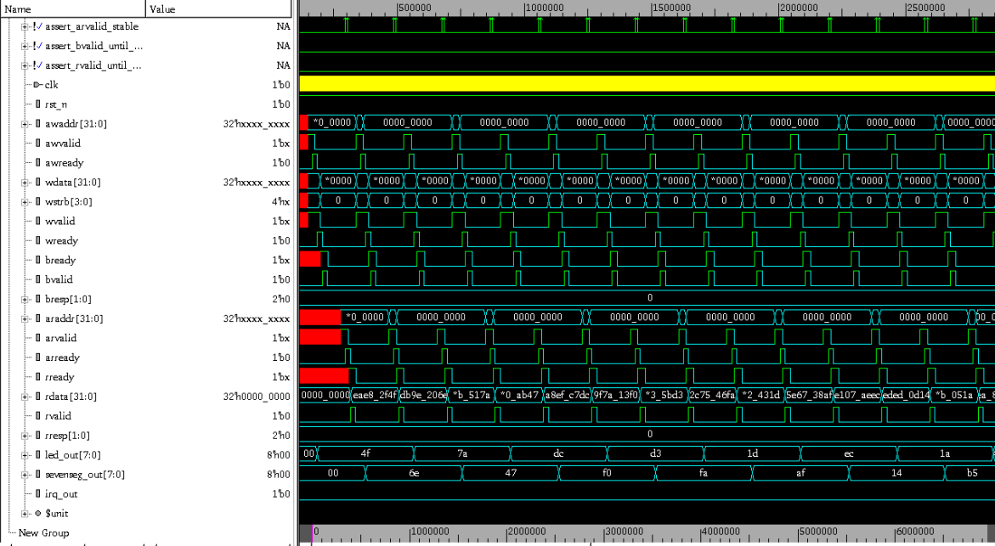

8. Concurrent test
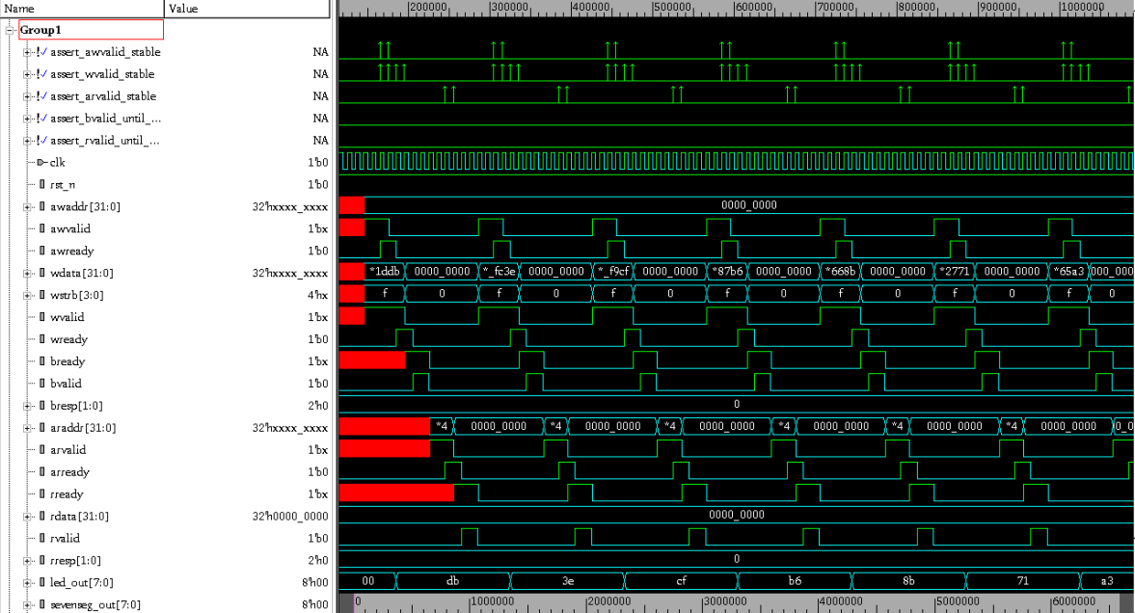

9. Stress test
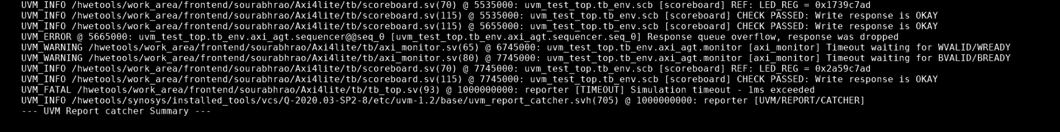
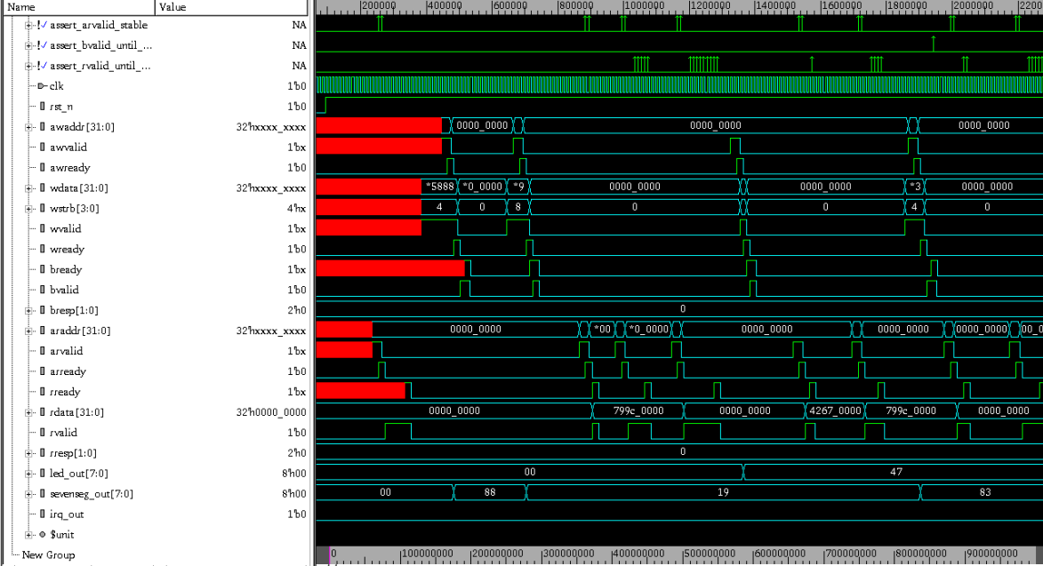

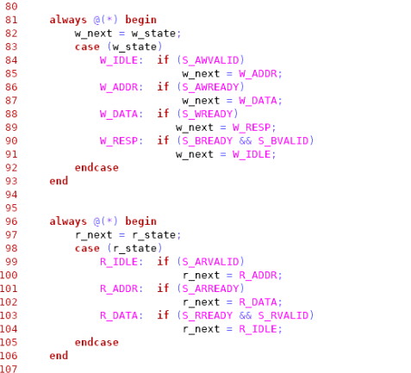
- In the address and data states (for both read and write operations), the next state transition was controlled only by the ready signal.
- However, according to the protocol specification, the state transition should depend on both valid and ready signals.
- To correct this, the code was modified to include the valid signal along with the ready signal for controlling the state transitions.

10. Unaligned addr test
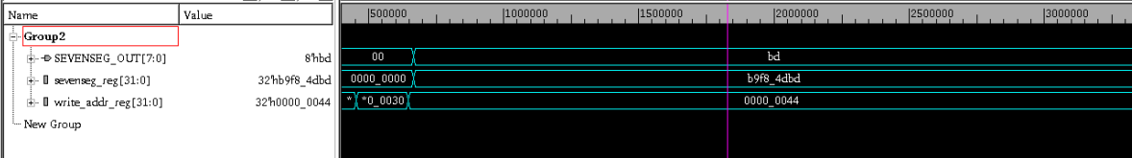
- Since for write and read logics in design are considering only [5:2] bits, even though unaligned addresses are targeted, for few addresses registers are getting access
- For non-specified register addresses. Ex: for 0x44 address sevenseg register is getting accessed and for 0x40 address led register is getting accessed.

Coverage report

